T: Thank you for the lesson. The lesson is over. Good-bye!

Проект урока
Тема: «Shopping for clothes»
Цель: формирование навыков диалогической речи по теме «Shopping for clothes»
Задачи:
Образовательная: повторить образование специальных и общих вопросительных предложений, научить использовать новые лексические единицы и речевые клише в диалогической речи.
Воспитательная: воспитывать культуру поведения в магазине через использование речевых клише.
Развивающая: развивать мышление, языковую догадку, развитие коммуникативных умений.
Оборудование: проектор, компьютер, интерактивная доска, мультимедиа приложение к учебнику.
Тип урока: урок постановки новой учебной задачи.

Ход урока:
I. Вводно-мотивационный этап
Организационный момент
T: Good morning, dear children!
P: Good morning, good morning!
Good morning to you,
Good morning, good morning,
We are glad to see you.
T: How are you boys? How are you girls?
P: We are fine, thank you.
T: What is the weather like today?
P: It is warm/cold.

T: What date is it today?
What day of the week is it today?
Phonetic exercise:
you don’t understand anything, choose black dress or suit and wear it on these people.

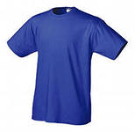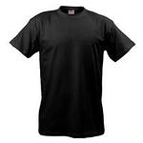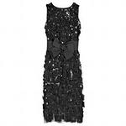

You should choose one of them. I give you 5 minutes to make up dialogues.
T: Ok. Time is up. Let’s check your dialogues. The first pair, come to the blackboard and act out your dialogue, please.
T: Thank you for your good work.
III. Рефлексивно-оценочный этап
T: Boys and girls you were very active at the lesson. I am glad. Now tell me, please. What was new for you? What have you learnt at the lesson?
Ch: We have learnt……
T: Yes, good for you. Write down your hometask:
- To learn by heart new words
- To make up word combinations and sentences.
- To draw yourself in your favourite clothes and describe them.
T: Now mark your knowledge, if you think that you have known many new information at the lesson, choose blue dress or suit. If you think that

T: Let’s do phonetic exercise. First of all listen to the announcer. Then repeat after him.
[ u:] [e] [ ʃ ] [ei]
room red shirt away
blue help T-shirt play
boots dress shoes raincoat
shoes sweater shorts trainers

Arina will you read the words with the sound [ei],…
T: Good. Now let’s play a game. We are in the food shop. ( game with a ball). I will ask you questions. You should answer these questions.
T: What would you like to buy in the shop?
P1: I would like to buy a cabbage.
P2: …..
P3: …..
T: Ok. Well done. Now look at the picture. What can you see on this picture?
Ch: It is a shop.
T: What shop is it?
Ch: We don’t know.
T: It is clothes shop. Can you name these clothes.
Ch: No, we can’t.
T: What do you think what will be the theme of our lesson?
Ch: Shopping for clothes
T: Yes, of course. The theme of our lesson is “Shopping for clothes”. What shall we do at the lesson?
Ch: We shall know new words about clothes.
We shall buy clothes in the shop.
T: Ok. What should you know to buy things in the clothes shop.
Ch: сколько стоит, узнать размер, названия одежды, цвета.
T: Excellent. You are right.

Ответ: She bought blue jeans and a brown T-shirt. Что мы узнали из текста?
Ch: Мы узнали как правильно задавать вопросы.
Физкультминутка
Now listen to the song and do as Panda (www.britishcouncil.org/kids-songs-olympics.htm).
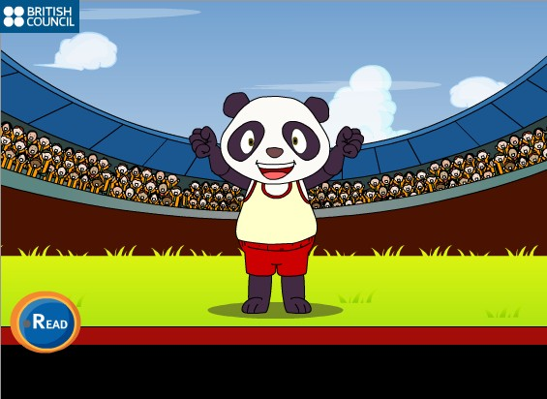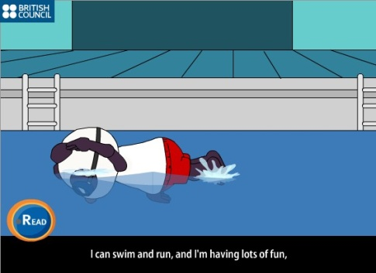

T: So, the next task for you is to make up your own dialogue “In the clothes shop”.
You will work in pairs. You would like to buy clothes:
- for your birthday party.
- for a picnic.

- What would you like to wear in autumn?
- What would you like to wear in summer?
- What would you like to wear in spring? Look at these sentences. Compare them. What are the differences between them?
- My jeans are blue.
- My cap is blue.
- My shorts are very small.
- My sweater is warm and small.
- Your trousers are very long.
- Your suit is big.
- My clothes are very fashionable.
The rule: Слова trousers, jeans, shorts, clothes употребляются только во множественном числе.
Now open your books at page 86, ex.5. Read this dialogue and answer the question: What did Miss Chatter buy in the shop?

II. Операционно-содержательный этап
Look at the pictures, listen carefully and then you will repeat.
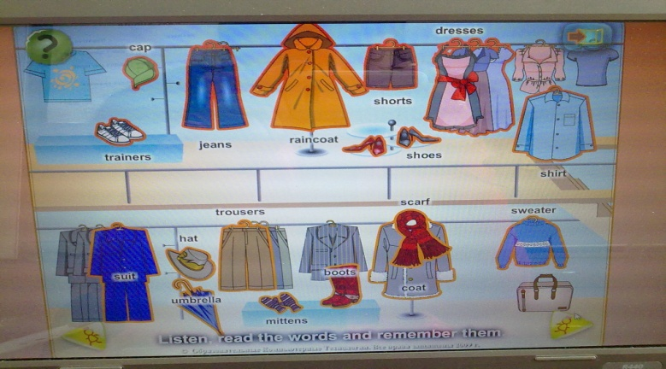
T: Now you should listen to it once again and tick the right picture. (аудирование)
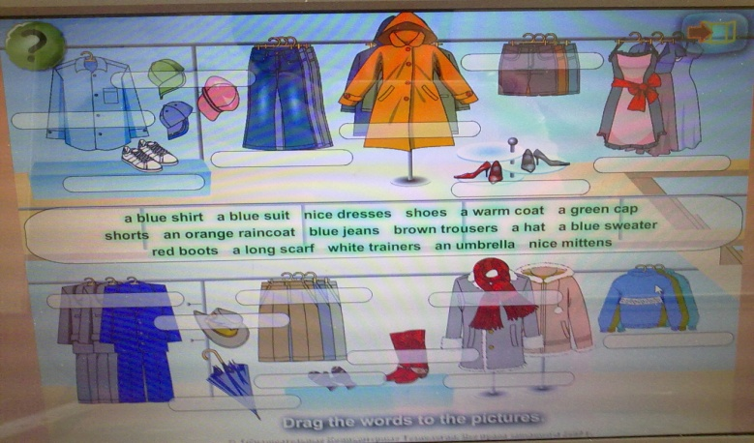
T: Good. Answer my questions.
- What would you like to wear in winter?

